# Background Knowledge

**Bancassurance** is an arrangement between a bank and an insurance company allowing the insurance company to sell its products to the bank's client base. This model operates in a way that bank staffs in bank branch are allowed to promote/share about the life insurance partner’s products to bank customers. If interested, bank staff will refer bank customer to life insurance agent. Life insurance agents are allowed to be stationed at bank branch and are licensed to both promote life insurance products and conduct insurance sale activities.

A life insurance company, ABC, has partnered with bank XYZ to run a bancassurance model.

* An ABC sale agent can station at a fixed XYZ branch to promote ABC products and conduct sale activities.
* An ABC sale agent can self-source for lead/prospect who visit the branch for various banking purposes to sell.
* Staffs at XYZ can promote ABC products and if the customer is interested, his/her contact information is passed to ABC sale agent who is located at the respective branch. Such customer is called a lead/prospect. If the sale agent able to sell the insurance policy to lead/prospect, sale is closed/converted. Prospect becomes the customer of the life insurance company.
* Bank customer can also introduce refer their friends and family directly to ABC sale agent when they visit the branch.

# Data Structure & Information

|  |  |
| --- | --- |
| **Table Name** | **Usage & Description** |
| Agent | Life Insurance Sale Agent  Records of all bancassurance agent hired by ABC. Fields inside this table contains information related to each insurance sale agent. |
| BankBranch | Bank Branch  Records of all bank branch of XYZ in different states. |
| BankReferral | Bank Referral  Records of all lead/prospect referred to ABC. |
| Customer | Record of all customers (Policy Owner) who has bought policy from ABC.  Customer information need to input and created before Policy information (in table InsurancePolicy table) can be created |
| InsurancePolicy | Insurance Policy  When a sale agent managed to close sale, the agent will submit product purchase application to ABC. After which the application will be reviewed and processed by back-office new business operation staffs. Once processed, an insurance policy (contract) will be issued to customer as proof of having a life insurance protection with ABC. Records of these insurance policy are stored in this table. |

**Entity Relation Diagram**

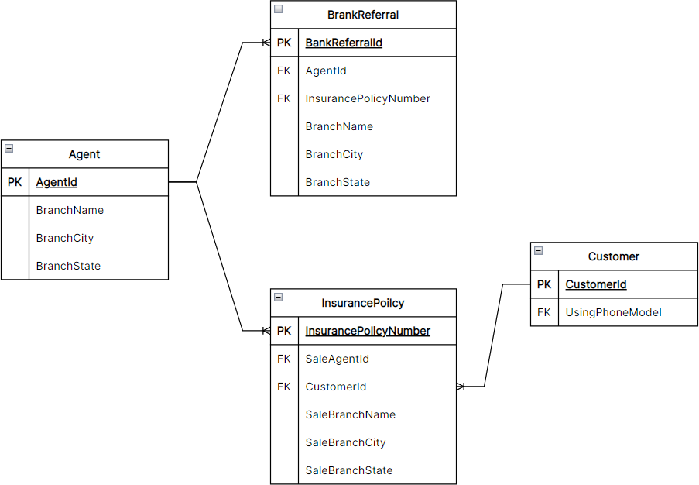

**Fields details in Agent table**

|  |  |
| --- | --- |
| **Field Name** | **Field Definition Description** |
| AgentId | Unique Id given to an insurance agent by the system to identify as ABC’s sale  agent. |
| TypeOfAgent | The distribution channel that the agent is operating under. Banca = Bancassurance channel |
| DateOfBirth | Agent info: date of birth |
| Gender | Agent info: gender |
| MaritalStatus | Agent info: marital status |
| DateOfJoiningCompany | Date agent officially start working for ABC as insurance sale agent. |
| DateOfResignation | Last day that the agent is with ABC. If value is *NULL* means the agent is still currently working for the company. |
| HighestEducationQualification | Highest education qualification attained by the agent |
| PreviousOccupation | Agent’s previous occupation before joining ABC as life insurance sale agent. |
| EmploymentStatus | Agent’s employment status with the company. ACTIVE/ RESIGNED |
| BranchName | Name of bank branch that the agent station at. |
| BranchCity | City that the bank branch is located in. |
| BranchState | State that the bank branch is located in. |

**Fields details in BankBranch table**

|  |  |
| --- | --- |
| **Field Name** | **Field Definition Description** |
| BranchName | Name of Bank Branch |
| BranchCity | City that the branch is located in. |
| BranchState | State that the branch is located in. |

**Fields details in BankReferral table**

|  |  |
| --- | --- |
| **Field Name** | **Field Definition** |
| BankReferralId | Unique Identifier generated by system to uniquely identify each referral records |
| ReferralSource | Source who referred the lead/prospect. |
| BranchName | Name of bank branch that lead/prospect was referred from. |
| BranchCity | City that bank branch is located in. |
| BranchState | State in which the city is located in. |
| ProspectSubmissionDate | Date prospect is submitted |
| ProspectGender | Prospect profile information: gender |
| ProspectMaritalStatus | Prospect profile information: marital status |
| ProspectChildInfo | Prospect profile information: child information (i.e. number of children) |
| ProspectOccupation | Prospect profile information: occupation |
| ProspectDateOfBirth | Prospect profile information: date of birth |
| ProspectAge | Prospect profile information: age |
| LatestActivityStatus | As part of the sale process, the agent will attempt contact the lead/referral and build relationship and provide financial consultancy.  Various status  **Received** – submitted referral has been received by the ABC.  **Contacted** – Agent assigned to the referral has established contact with him/her. **Scheduled Meeting** – Agent has managed to schedule face-to-face meeting with prospect.  **Meeting** – Agent has met face-to-face with prospect.  **Presentation** – Agent has conducted sale presentation to prospect.  **Policy Submitted** – Agent has successfully closed sale.  **Not Successful** – Agent has failed to convinced customer to purchase any insurance. |
| ProspectToCustomer | Status of sale conversion.  ASSIGNED – Referral has been assigned to agent  IN-PROGRESS – Agent has started some activities with the referral SUCCESSFUL – Agent has successfully close sale.  UNSUCCESSFUL – Agent has failed to close any sale. |
| ProspectAssignedToAgent DateTie | Date/time prospect is assigned to an agent |
| AgentId | Id of agent that this referral is assigned to |
| InsurancePoilcyNumber | If sale conversion is successful, and insurance policy has been issued then this field will have value of PolicyId that has been sold to this customer. |

**Fields details in Customer table**

|  |  |
| --- | --- |
| **Field Name** | **Field Definition Details** |
| CustomerId | Unique Identifier generated by system to uniquely identify each customer records.  When dealing with ABC, customer can present this ID as their reference records. |
| DateOfBirth | Customer info: Date of Birth |
| Gender | Customer info: Gender |
| MaritalStatus | Customer info: Marital Status |
| ResidentialState | Customer info: State in which customer reside in |
| ChildCount | Child info. If *NULL* mean information not available. |
| AssetCarCount | Number of car(s) customer owns. If *NULL* mean information not available. |
| AssetHouseCount | Number of house(s) customer owns. If *NULL* mean information not available. |

|  |  |
| --- | --- |
| OccupationGroup | Occupation grouping by back-office operation team |
| Occupation | Customer’s occupation |
| HasLoan | Loan indicator to indicate if the customer has any loan (e.g. car loan, mortgage)  **Y**=has loan, **N**=no loan |
| HasMedicalHistory | Indicator to indicate if the customer any notable medical history.  Value: Y/N |
| UsingPhoneModel | Phone Model that customer is currency using |
| HasPet | Indicator to indicate if customer has any pet. |

**Fields details in InsurancePolicy table**

|  |  |
| --- | --- |
| **Field Name** | **Field Definition Details** |
| PolicyNumber | Unique identifier generated by system |
| ProductCode | Code representing product that is bought by the customer |
| SaleAgentId | Id of agent who sold the policy (i.e. submitted the application) |
| SaleBranchName | Bank branch name |
| SaleBranchCity | City that the bank branch is located in |
| SaleBranchState | State that the city is located in |
| SubmissionDate | Date agent submitted the purchase application |
| IssuanceDate | Date purchase application processed, and insurance policy (contract) issued i.e.  effective date of insurance policy that ABC starts insuring customer. |
| **PolicyStatus**\* | Status of insurance policy in various stages. This is important field to know which  state customer’s policy insurance policy validity is in.  Refer to appendix for more details of this fields. |
| PremiumFrequency | The frequency at which the premium is paid to keep the life insurance policy benefits active or in-force. The proposer can choose to pay the premium on annual, semi-annual, quarterly or monthly basis within a year. “Single premium” life insurance is a form of life insurance that's paid with one upfront lump-sum premium.  Insurance premium is the amount of money an individual or business pays for an  insurance policy on regular basis to keep the policy effective. |
| CaseSize | Annualize premium |
| CustomerId | Id of customer who bought and own this policy. Link to **Customer** table. |

Company Product details

|  |  |  |  |  |
| --- | --- | --- | --- | --- |
|  |  |  | **Insurance Premium Range per annum in US Dollars** | |
| **Product Code** | **Product Name** | **Product Description** | **Min** | **max** |
| BT6 | Life Protect | A pure protection product which only provides insurance cover in the event of death or incapacity due to illness and nothing otherwise | 100 | Unlimited |
| BT4 | Big Savings | This product is suited for customers who intent to save a considerable amount of money towards a life goal which could be children's education, wedding etc. this also has a protection element which provides a lump sum amount in case of death. | 300 | Unlimited |
| BT5 | Small Savings | This product is suited for customers who intent to save amount of money towards smaller life goals such as small family holiday, car, family holiday, medical expenses. this also has a protection element which provides a lump sum amount in case of death. | 50 | 5,000 |

|  |  |  |  |  |
| --- | --- | --- | --- | --- |
| MT1 | Home Safe Loan | Loan protection insurance which covers debt payments on certain covered loans if the insured loses their ability to pay due to a covered event. Such an event may be disability or illness or  death. | 6,000 | 1,000,000 |
| MT2 | Small Loan | Loan protection insurance which covers debt payments on certain covered loans if the insured loses their ability to pay due to a covered event. Such an event may be disability or illness or death. This product is suited for personal loans such as car, holiday, house interior etc | 100 | 10,000 |

QUESTIONS

**SECTION #1 – Calculation**

Submission instruction:

Please complete question below by referring to required output format and definition provided in **PCLA DS Test - Answer.xlsx** accordingly to their respective sheet

(sheet name: **S** {*section #*} **Q** {*question#*}.

Fill each sheet data table with resulted data and share SQL code query for answer to each question please share in .sql file with respective naming. i.e. S1Q01 – Answer Query.sql

1. Total no. of active sales agents, total no of prospects received, total number of policies sold, and total amount of premium received (CaseSize) in 2021, 2022 respectively.

**Note:**

* + Policy only considered sold when they are issued (i.e. there is Issue Date).
  + Active sales agent in a given is defined as agent who has joined and work for ABC at least a 30 calendar days before resigning.

1. Average agent productivity month on month (Productivity = Total Cases sold / respective unit of days) in 2021, and 2022.

**Note:**

* + Case sold = policy submitted
  + Not all agents sold any policy in a given month, please still show them with productivity 0.
  + Not all branch state has any policy sold (submitted), but please show them with productivity 0.

1. Calculate sales agent conversion rate month on month in 2021, 2022 respectively.

**Note:**

* + Date to include in period is date prospect submission date.
  + Conversion Rate = {# of policies sold} / {# of prospects received}

**SECTION #2 – Visualization**

Submission instruction:

Please share screenshot in **PCLA DS Test - Answer.xlsx** accordingly to their respective sheet (sheet name: **S**{*section #*}**Q**{*question#*}. And share PowerBI working file.

## Produce a chart for number of prospects in every state and total number of policies sold

1. Produce a chart on sources of prospects to Sales Agents and their respective prospect conversion rates
2. Produce a country map visualization for number of prospects received from each state in red color and no of policies sold in green

**SECTION #3 – Business Insight and Scoring Model**

Share your insights and model on

1. Best performing Sales Agents in region and their profile
2. Preferred customer profiles/segments to be targeted on priority

**SECTION #4 – Business Strategy**

1. Recommend sales agent profile to be recruited, by region and overall.
2. Strategy to map agents with potential prospects, and missing piece of information you would desire as a data scientist/analyst in existing data.

APPENDIX

**Policy Status**

Below statuses, are after purchase application is successfully submitted and prior to application is process and policy is issued and become effective for customer.

Figure 1: High level diagram of flow of insurance policy status.

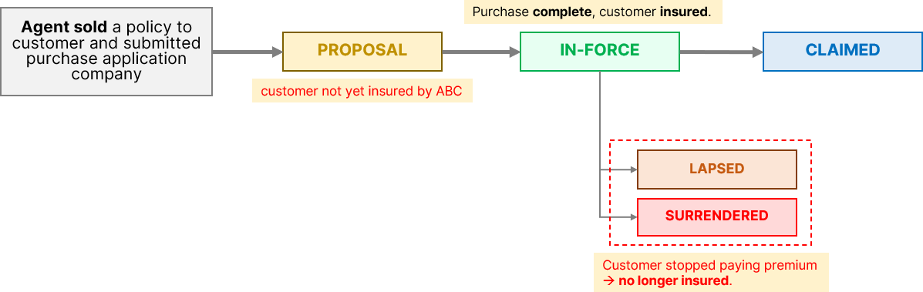

|  |  |
| --- | --- |
| **Policy Status** |  |
| **PROPOSAL** | Purchase application is submitted and pending processing by new business operation team. |
| **IN-FORCE** | This is **key status** that indicate that policy is effective, and ABC is insuring the customer. If customer continue to pay premium regularly.  From this status onwards, the insurance policy sale is considered fully completed by the agent and revenue has been booked into ABC. |
| **LAPSED** | Lapse is a key insurance business term to indicate the insurance policy has not been renewed,  i.e. customer has not paid any premium due for extended period. Once customer comes back and pay all outstanding premium due, insurance policy protection will be renewed and thus status will go back to IN-FORCE. |
| **SURRENDERED** | Customer decided to surrender the insurance policy and not continue paying any premium. Thus insurance policy no longer valid. |
| **CLAIMED** | Customer has met with an unfortunate event and thus entitled to insurance claim. This status indicated that the insurance beneficiary has claim the protection amount. |